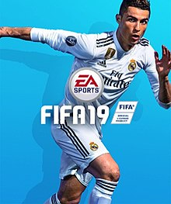

|  |  |
| --- | --- |
|  | |
| [**Developer**](https://en.wikipedia.org/wiki/Video_game_developer) | [EA Vancouver](https://en.wikipedia.org/wiki/EA_Vancouver) [EA Romania](https://en.wikipedia.org/wiki/Electronic_Arts#Company_structure) |
| [**Publisher**](https://en.wikipedia.org/wiki/Video_game_publisher) | [EA Sports](https://en.wikipedia.org/wiki/EA_Sports) |
| [**Composer**](https://en.wikipedia.org/wiki/Video_game_composer) | [Hans Zimmer](https://en.wikipedia.org/wiki/Hans_Zimmer) [Lorne Balfe](https://en.wikipedia.org/wiki/Lorne_Balfe) |
| **Series** | [*FIFA*](https://en.wikipedia.org/wiki/FIFA_(video_game_series)) |
| [**Engine**](https://en.wikipedia.org/wiki/Game_engine) | [Frostbite 3](https://en.wikipedia.org/wiki/Frostbite_(game_engine)) (PS4, XOne, PC) |
| [**Platform**](https://en.wikipedia.org/wiki/Computing_platform) | * [Microsoft Windows](https://en.wikipedia.org/wiki/Microsoft_Windows) * [PlayStation 3](https://en.wikipedia.org/wiki/PlayStation_3) * [PlayStation 4](https://en.wikipedia.org/wiki/PlayStation_4) * [Xbox 360](https://en.wikipedia.org/wiki/Xbox_360) * [Xbox One](https://en.wikipedia.org/wiki/Xbox_One) |
| **Release** | 28 September 2019 |
|  |  |
|  |  |